National Institute of Technology Karnataka, Surathkal

Department of Computer Science and Engineering

CS302 - Computer Networks Lab

Packet Tracer Assignment – Week 4 Questions



Submitted by:

Name: Manas Trivedi  
Roll no.: 181CO231  
Reg. no.: 181711

Odd Semester 2020-2021

Q1)

Screenshot of the network before configuration of individual devices,

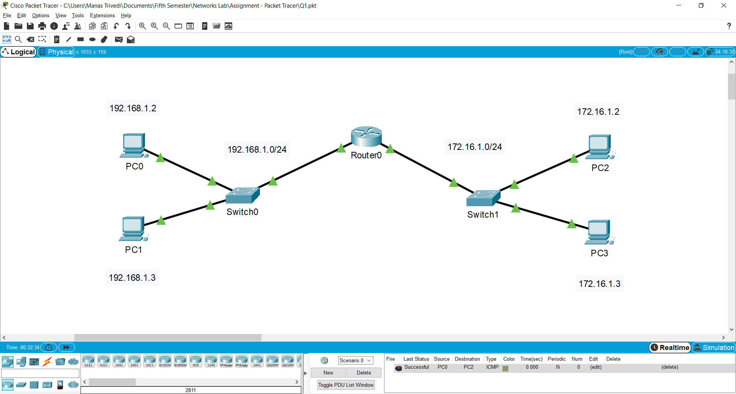

Configuring Hostname of Router0,

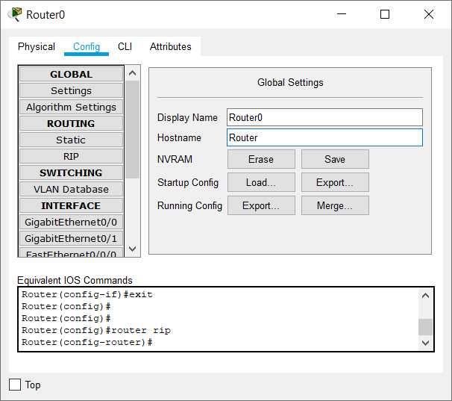

Setting IP address and subnet mask for GigabitEthernet0/0 interface,

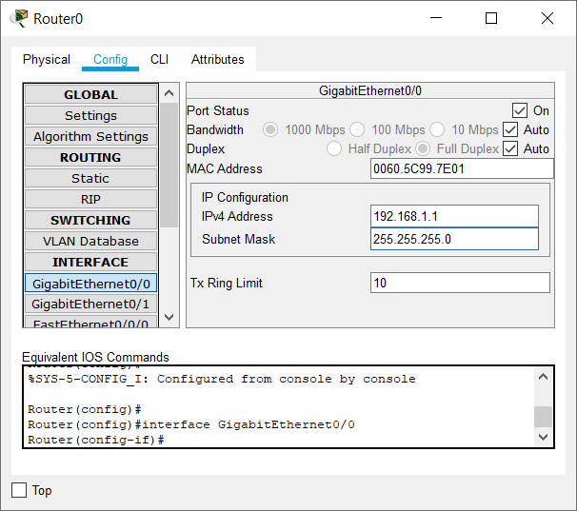

Setting IP address and subnet mask for GigabitEthernet0/1 interface,

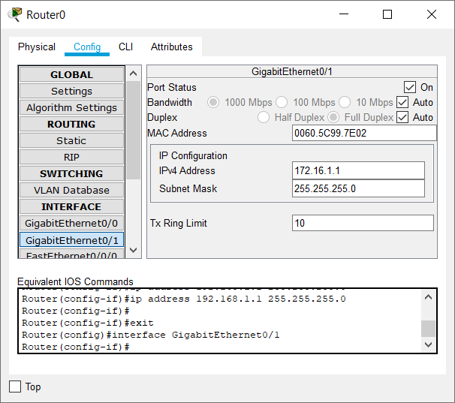

Setting default gateway, IP address, and subnet mask for PC0,

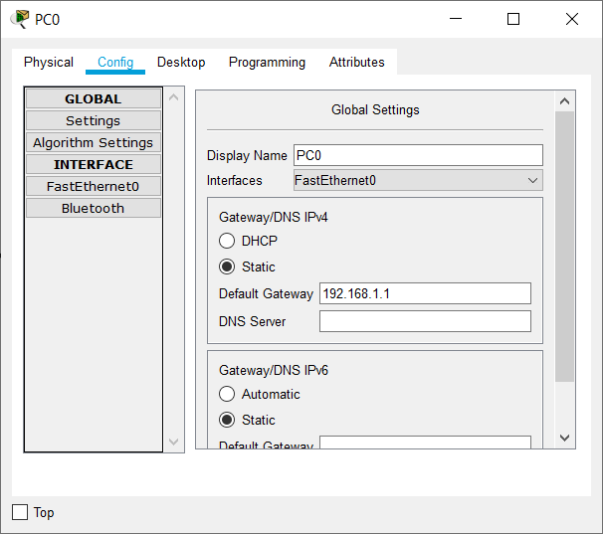 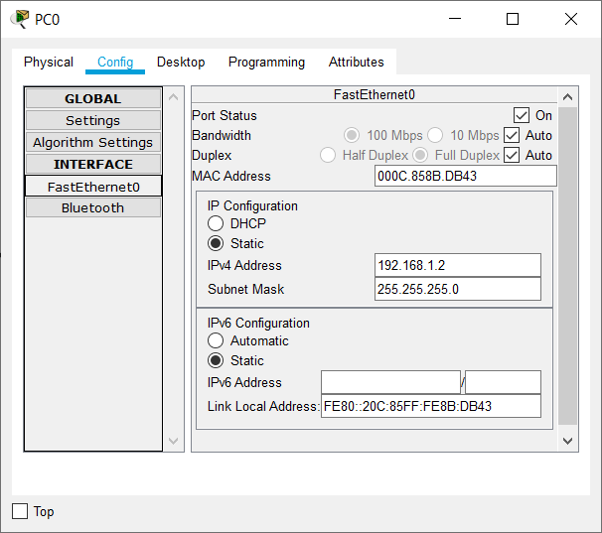

Setting default gateway, IP address, and subnet mask for PC1,

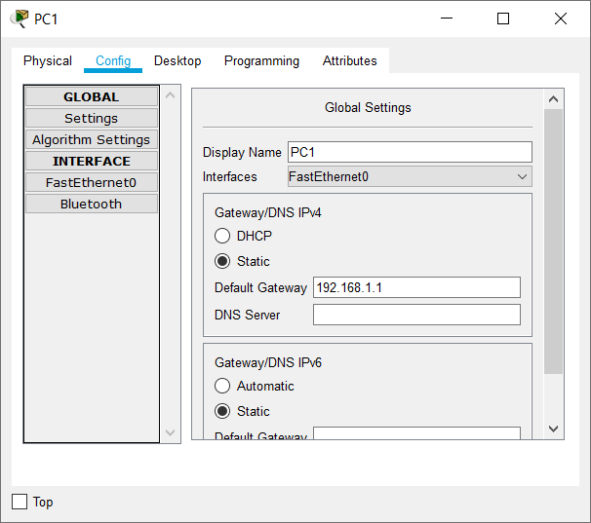 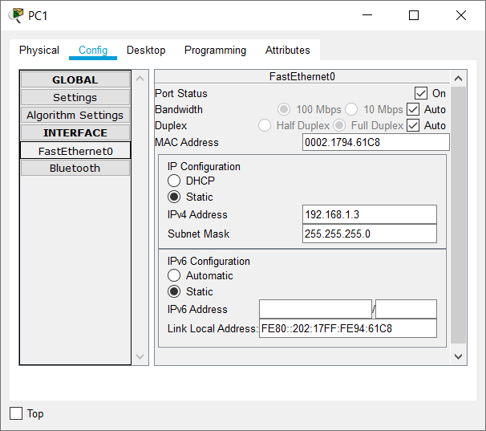

Setting default gateway, IP address, and subnet mask for PC2,

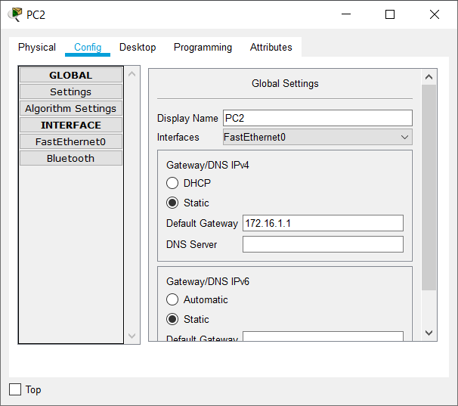 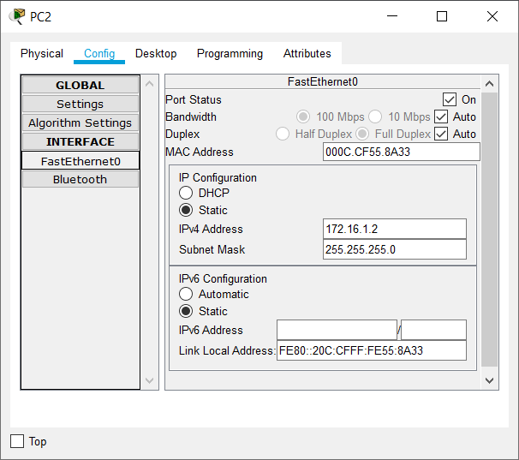

Setting default gateway, IP address, and subnet mask for PC3,

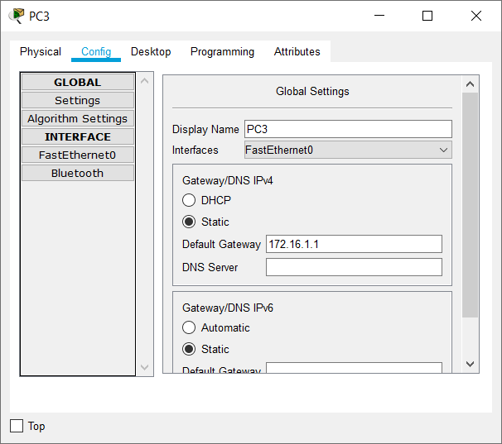 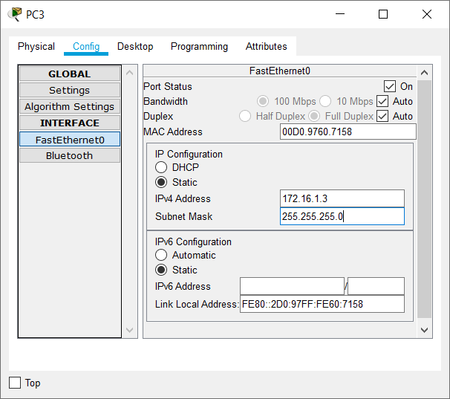

The configuration of the network is complete. Sending a ping to PC2 from PC3,

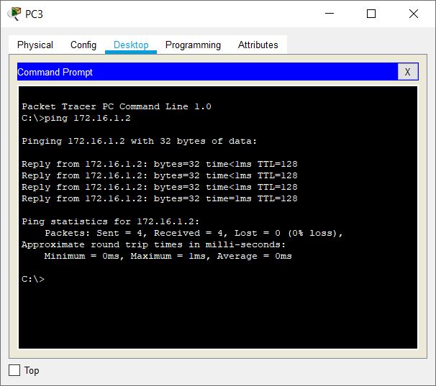

Sending a ping to PC3 from PC1,

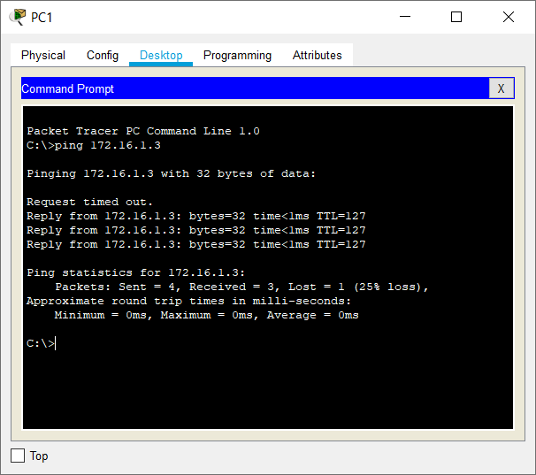

Q2)

Screenshot of the network before configuration of individual devices,

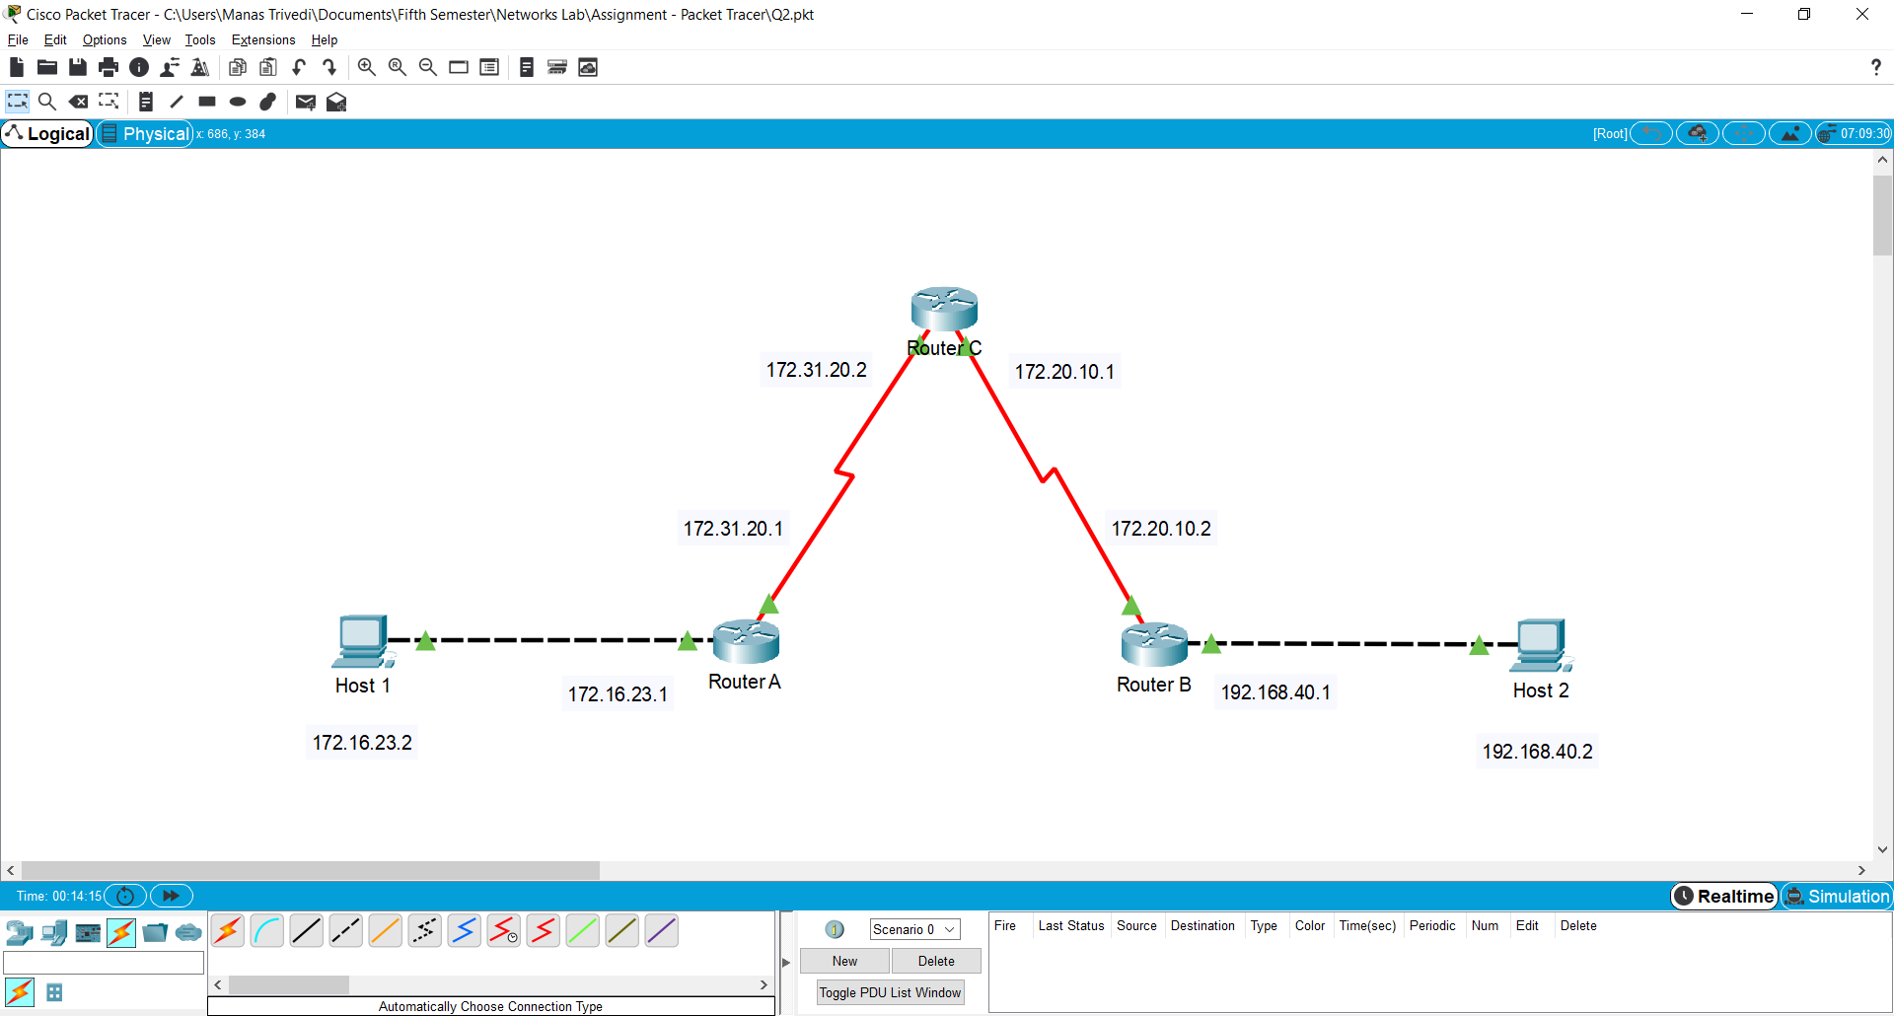

Setting default gateway, IP address, and subnet mask for Host 1,

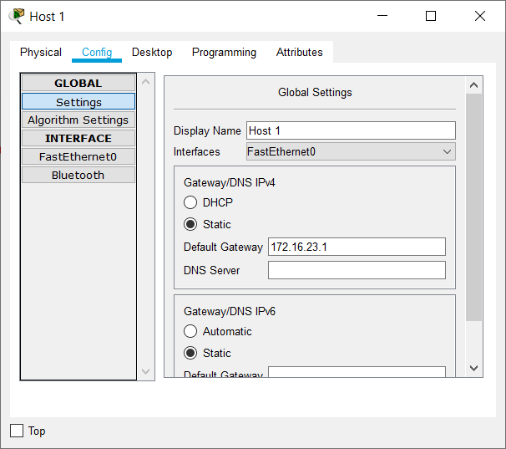 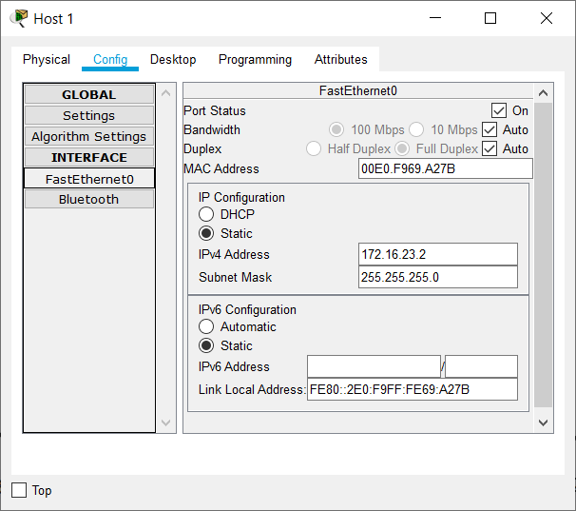

Setting default gateway, IP address, and subnet mask for Host 2,

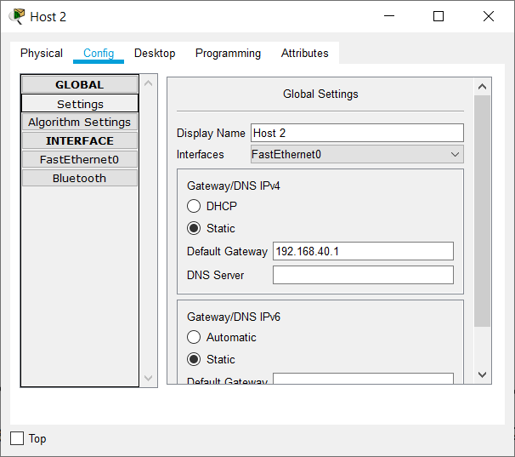 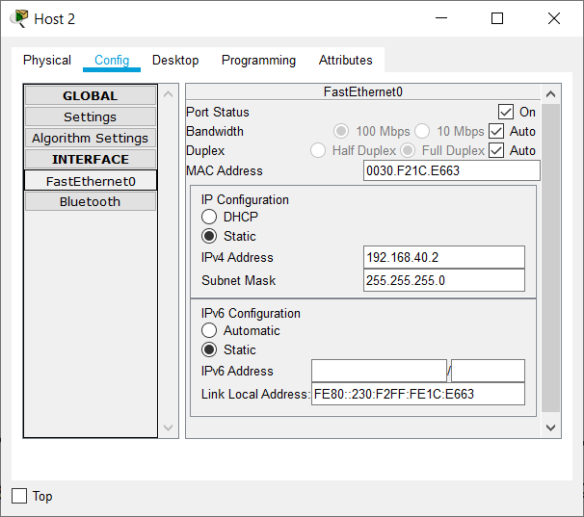

Setting IP addresses and subnet masks for FastEthernet0/0 and Serial0/2/0 interfaces of Router A,

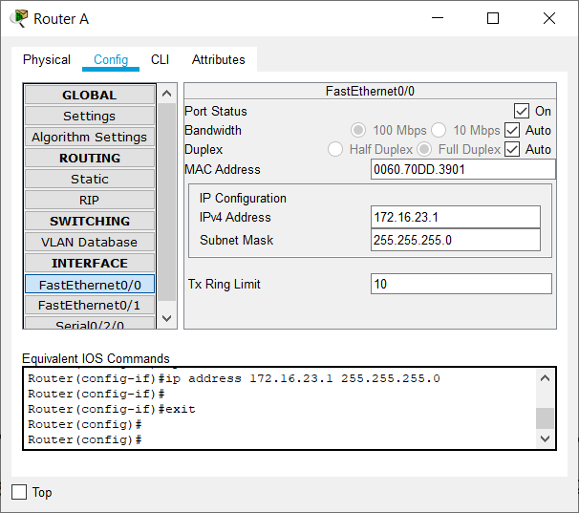 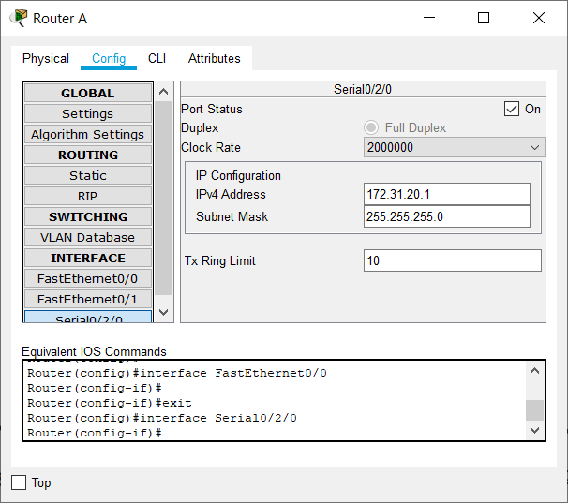

Setting IP addresses and subnet masks for FastEthernet0/0 and Serial0/0/0 interfaces of Router B,

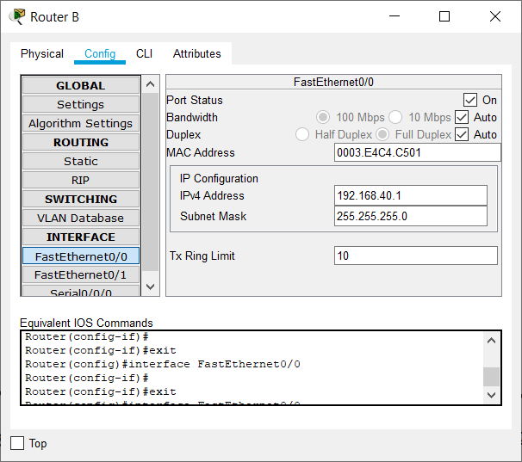 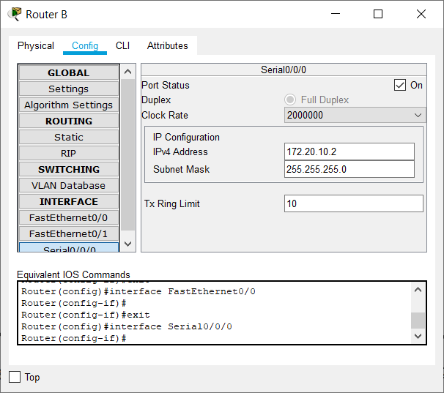

Setting IP addresses and subnet masks for Serial0/0/0 and Serial0/1/0 interfaces of Router C,

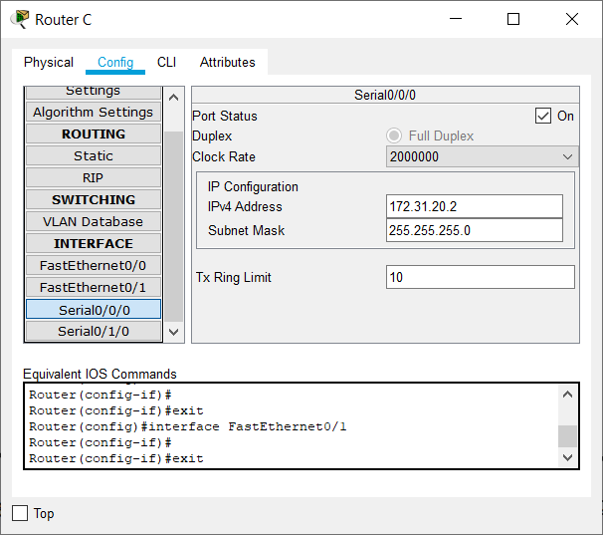 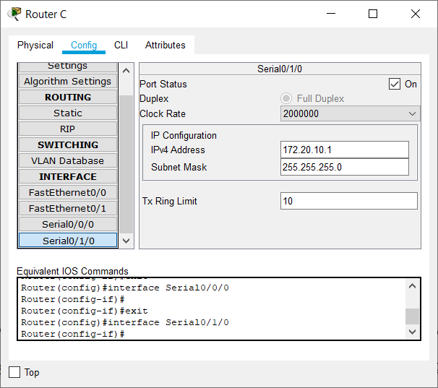

Static Routing of Router A, Router B, and Router C,

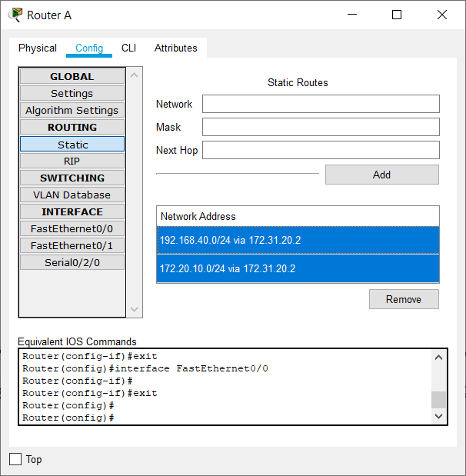 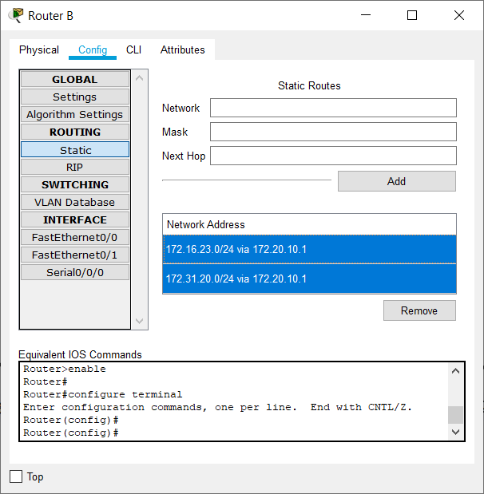 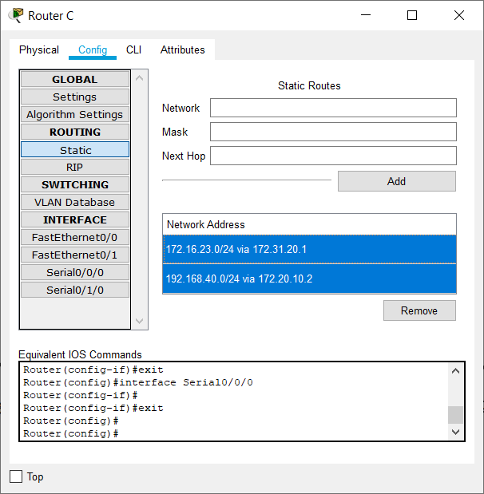

Sending a ping to Host 1 from Host 2,

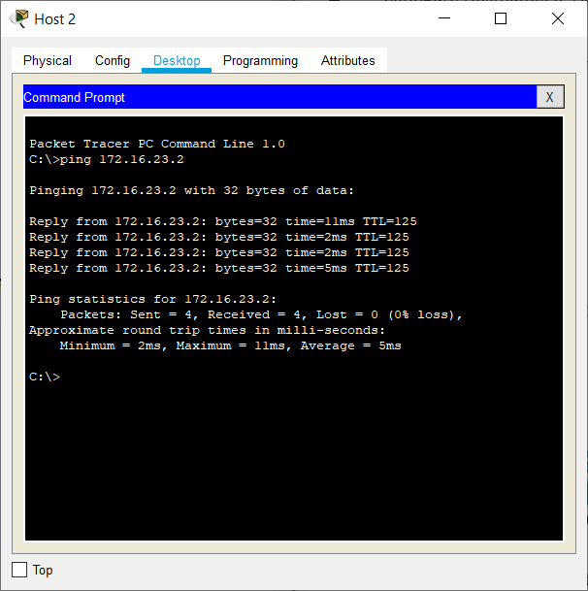

Sending a ping to Host 2 from Host 1,

